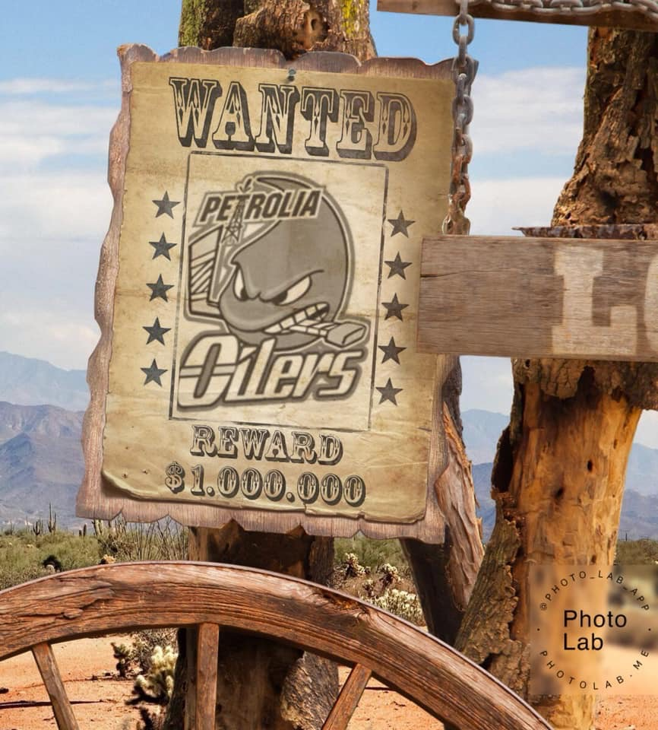

Save the Date: Saturday October 19th 7:30pm
Oilers Bantam Rep Boys presents
Country Western Night at the arena.
Wear your Cowboy boots & hats, come cheer on the boys in Western style!
Bring your donations of unwrapped toys and can goods in support of Christmas for Everyone and Petrolia food bank.
See ya’ll there. Yahoo Oilers!

